TC-REF-002
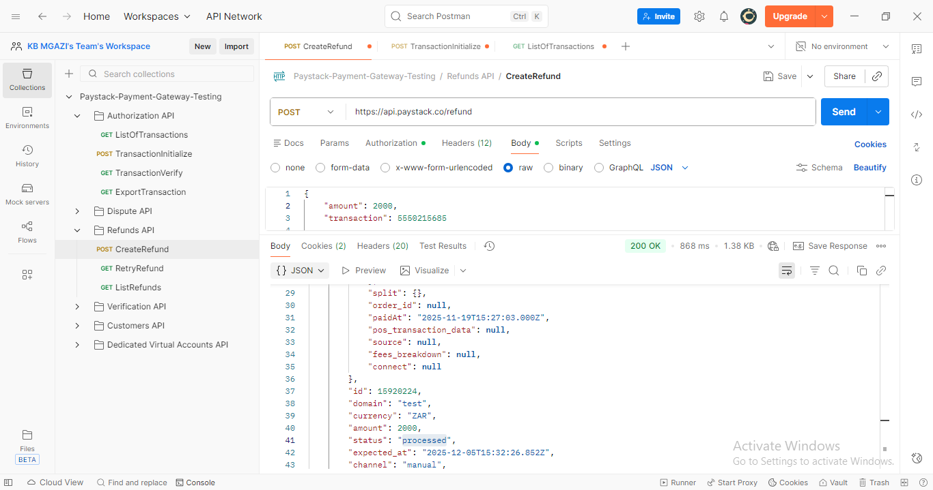
Request:
{
"amount": 2000,
"transaction": 5550215685

}

Response:
{
"status": true,
"message": "Refund has been queued for processing",
"data": {
"integration": 1642714,
"transaction": {
"id": 5550215685,
"domain": "test",
"reference": "7xo67qje50",
"receipt_number": null,
"amount": 7557,
"paid_at": "2025-11-19T15:27:03.000Z",
"channel": "card",
"currency": "ZAR",
"metadata": "",
"authorization": {
"exp_month": null,
"exp_year": null,
"account_name": null
},
"customer": {
"international_format_phone": null
},
"plan": {},
"subaccount": {
"currency": null,
"is_verified": false
},
"split": {},
"order_id": null,
"paidAt": "2025-11-19T15:27:03.000Z",
"pos_transaction_data": null,
"source": null,
"fees_breakdown": null,
"connect": null
},
"id": 15920224,
"domain": "test",
"currency": "ZAR",
"amount": 2000,
"status": "processed",
"expected_at": "2025-12-05T15:32:26.852Z",
"channel": "manual",
"refunded_by": "gmail",
"customer_note": "Refund for transaction 7xo67qje50",
"merchant_note": "Refund for transaction 7xo67qje50 by mgazikb@gmail.com",
"deducted_amount": 2000,
"fully_deducted": true,
"reason": "PROCESSED",
"customer": null,
"initiated_by": "gmail",
"session_id": null
}
}

